Zachary Weiss

ME570 HW5a

Professor Tron

10 December 2020

*Q1.1*:

Plots of visibility_isVisible_test by start location.

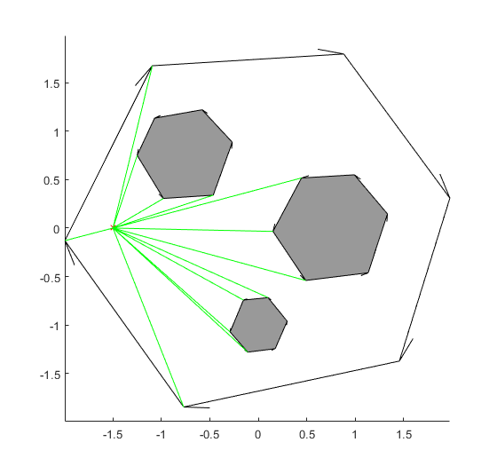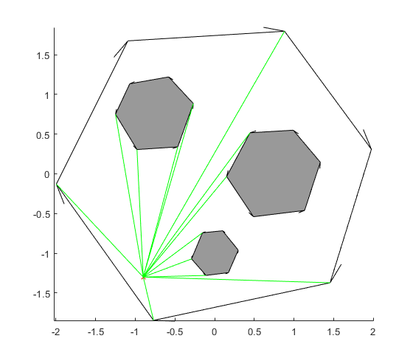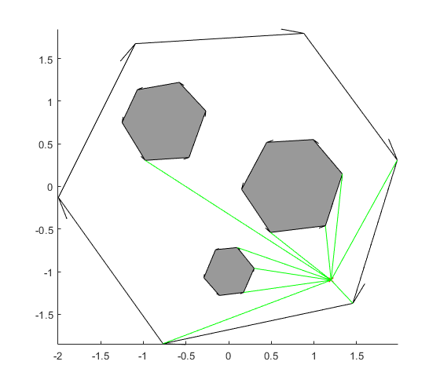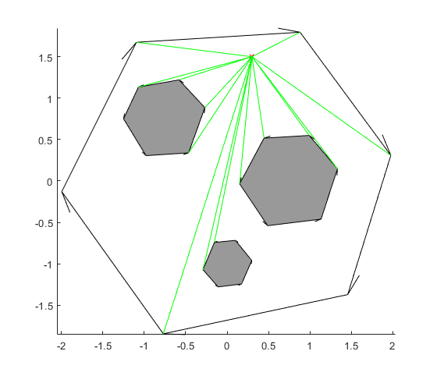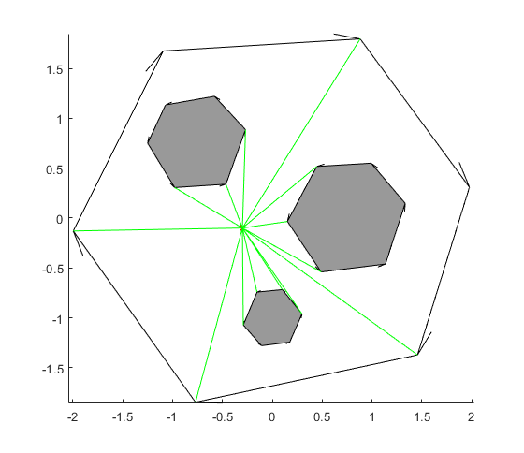

*Q1.2*:

Plots of found paths with visibility_search_test.

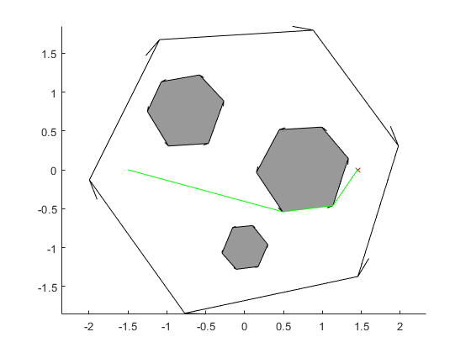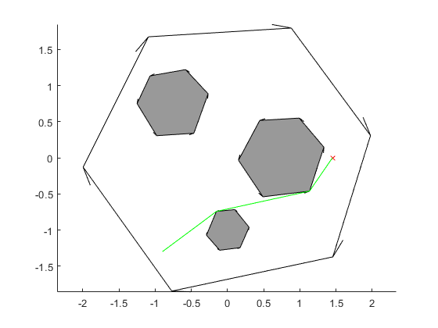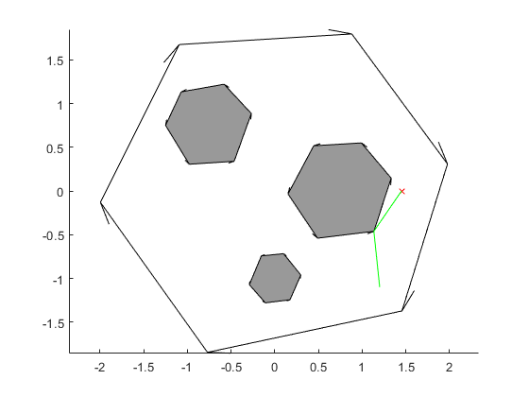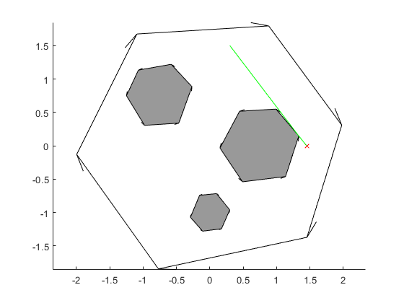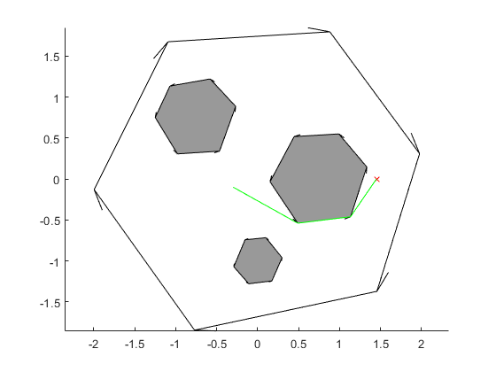

*Q1.3*:

The visibility roadmap finds optimal by length (to the resolution of the polygonal representation) paths, taking the straightest path to each corner whereupon it finds the straightest path to the next obstacle corner or the goal (the only instance in which this is not the case is where the goal is visible from the start, which, without a check of visibility between the two, leads to first moving to the nearest vertex of the surrounding geometry, before moving to the goal). In the graph search discretization of the sphere world, paths were limited to rectilinear or 45 degree moves on a grid of given resolution, and as such could not take the shortest paths (the hypotenuses about the obstacles) without changes to the algorithm / grid structure. Another impact of this design is that the most optimal solution returned could vary by discretization resolution used, but along with greater resolution came longer runtimes, both in the graph search and the discretization itself (the visibility graph is quite minimal, only connecting vertices within the environment, and can be pruned more with a reduced visibility graph). Compared to the potential-based methods, paths were sharper, but shorter, and had no possibility of being caught at local minima (and additionally necessarily converges in finite time, given a feasible path exists).

*Q2.1*:

This homework was the shortest of the bunch, likely clocking in at 7ish hours total, the majority of which was spent debugging and messing with the autograder / oddities in the specifications document. All in all was fairly straightforward, only real suggestions for improvement would be ensuring the specifications document and the autotests align, plus perhaps more verbose autotest errors such that problems are reproducible (and subsequently easier to debug) in one’s local MATLAB environment.